Kalanjali 2026 Registration Portal

User Guide

Welcome
Welcome to the Kalanjali 2026 Registration Portal.
This portal allows participants to register online for various Kalanjali 2026 competitions. Please read the instructions carefully before submitting your registration.

Accessing the Portal
- Open the registration link in your preferred web browser. : https://kalanjali2026tvm.netlify.app/
- The registration form will load automatically.
- No login or account creation is required.
- Only one participant per aadhar number is allowed to register.

Participant Registration
* All the fields are Mandatory
- Name
- Date of Birth (Click on the calendar icon marked below and select the date)
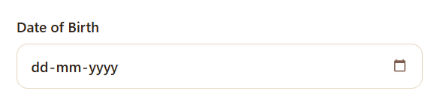

- Age will be automatically populated based on the Date of birth, You are NOT allowed to edit Age manually.
- Gender (Select Gender from the Dropdown)
- Mobile Number (DO NOT add +91, Just add you 10 digits mobile number).
- Aadhar Number (DO NOT add “-” in between, while you type the “-” will automatically come)
- Upasabha (Select your upasabha from the dropdown)

Once you have entered all the required details, the Events dropdown will automatically display the events you are eligible to participate in.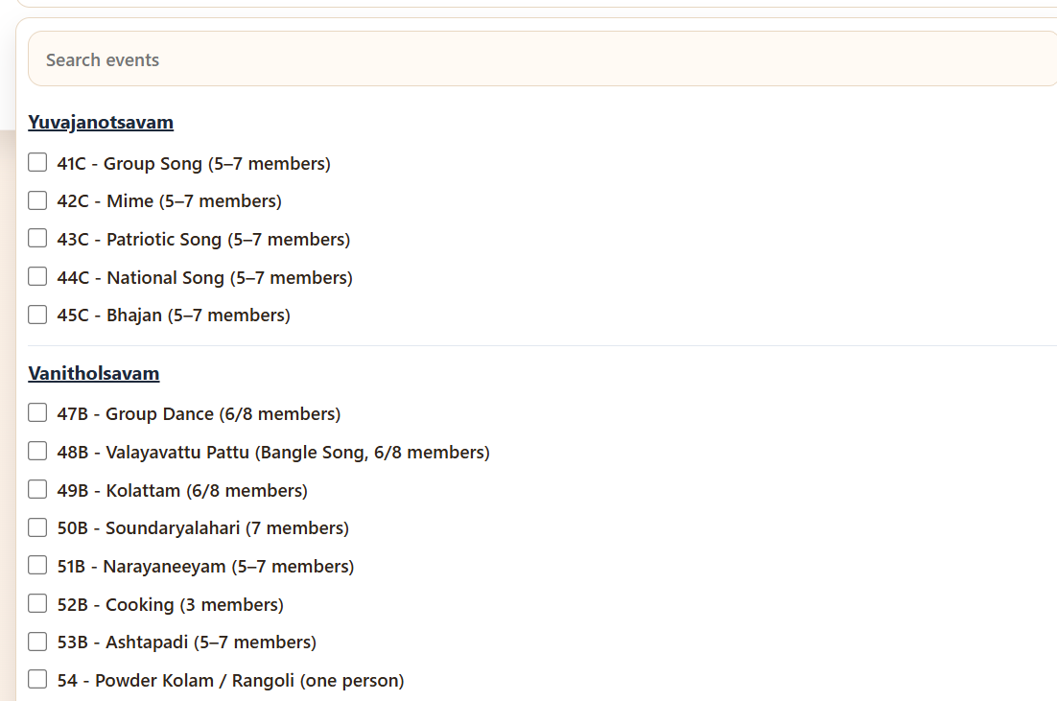
This year's competitions are organized under three main categories:
- Yuvajanotsavam
- Vanitholsavam
- Balolsavam
Based on the participant's age and date of birth, the system will automatically display the events the participant is eligible to participate in.
To register for events, simply select the checkbox next to each event that the participant wishes to participate in. You may select all eligible events, subject to the event rules and participation limits.
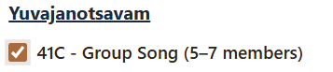

Once you select the checkbox, the event will get populated on the top as tags.
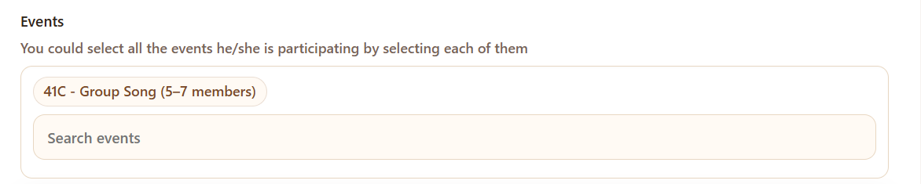
If you wish to remove a selected event, simply uncheck the corresponding checkbox in the Events dropdown. The event will automatically be removed from the Selected Events list.
Note: There is a limit to the number of events a participant can register for. Please refer to the participation guidelines issued by Kerala Brahmanasabha before making your selections.
Once you have selected all the desired events, click the Submit button to complete your registration.
If the registration is successful, a confirmation message will be displayed on the screen. It is recommended that you take a screenshot of the confirmation message for your records.
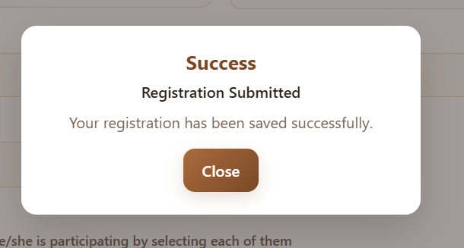
Please ensure that you are getting this Success Confirmation message on submit.

